**Tabel in HTML**

HTML tables allow web developers to arrange data into rows and columns.

<table>

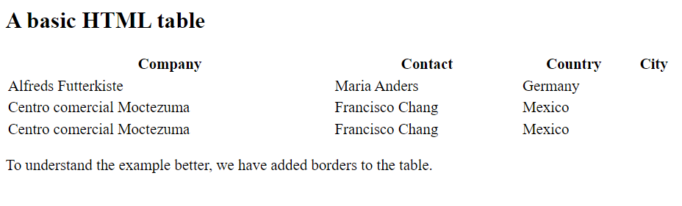

</table>

<td>

<td>

<td>

<tr>

